**DAILY ONLINE ACTIVITIES SUMMARY**

|  |  |  |  |  |  |  |  |  |
| --- | --- | --- | --- | --- | --- | --- | --- | --- |
| **Date:** | **05/06/2020** | | | | | **Name:** | **Spoorthy Balaji** | |
| **Sem & Sec** | **6th & B** | | | | | **USN:** | **4al17cs098** | |
| **Online Test Summary** | | | | | | | | |
| **Subject** | | **PAP Assignment 2, OR** | | | | | | |
| **Max. Marks** | | **PAP: 20**  **OR: 30** | | **Score** | | | **PAP: 15**  **OR: 30** | |
| **Certification Course Summary** | | | | | | | | |
| **Course** | **Introduction to Cyber Security** | | | | | | | |
| **Certificate Provider** | | | **Great Learning Academy** | | **Duration** | | | **7hours** |
| **Coding Challenges** | | | | | | | | |
| **Problem Statement:**  1.Write a Java program to implement Circular Linked List Using Array And Class  2. Python program to square each odd number in the list  3. **The program takes a string and removes the nth index character from the non-empty string.** | | | | | | | | |
| **Status: Solved** | | | | | | | | |
| **Uploaded the report in Github** | | | | | **yes** | | | |
| **If yes Repository name** | | | | | <https://github.com/spoorthybalaji/Daily_Status> | | | |
| **Uploaded the report in slack** | | | | | **yes** | | | |

IA TEST

PAP Assignment 2

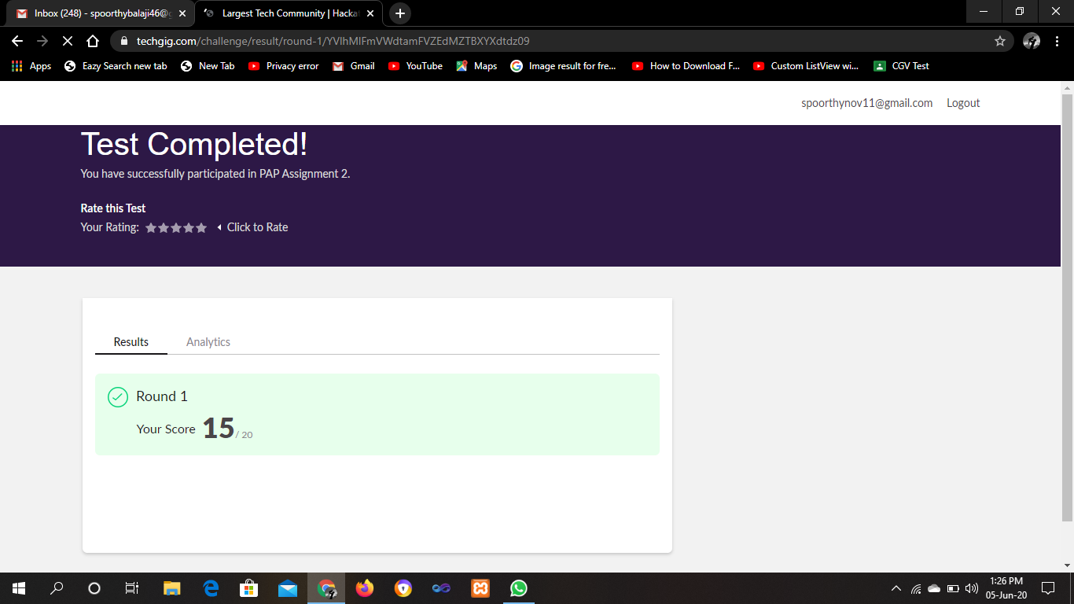

OR IA Test 3

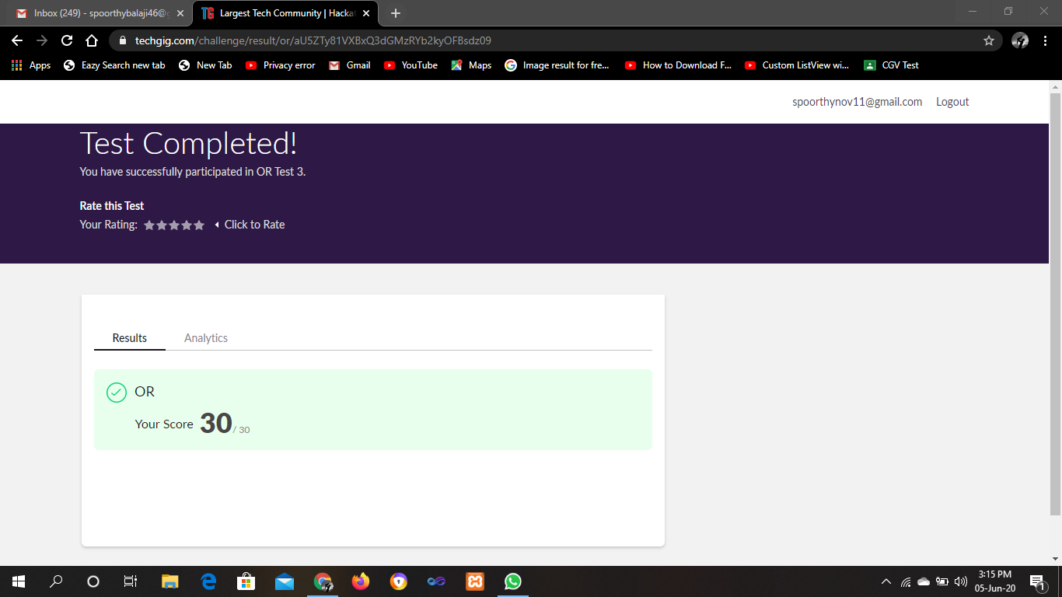

CERTIFICATION COURSE

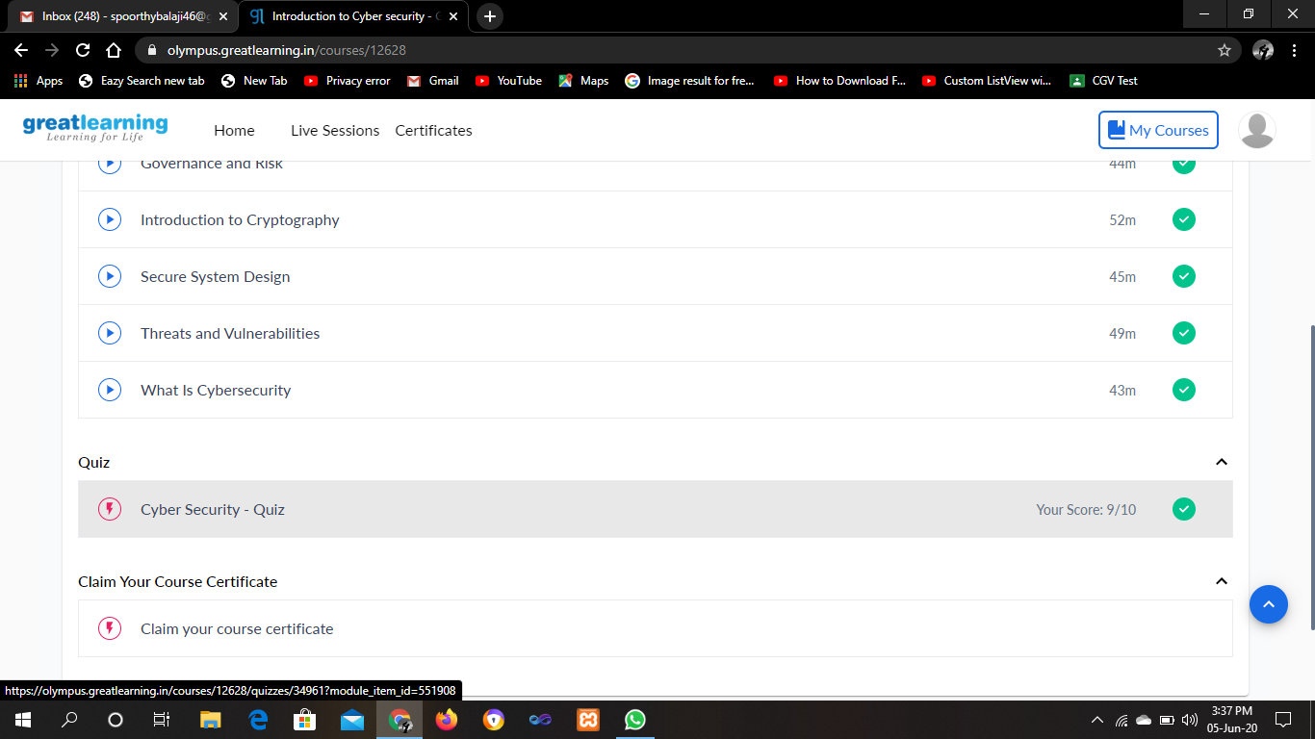

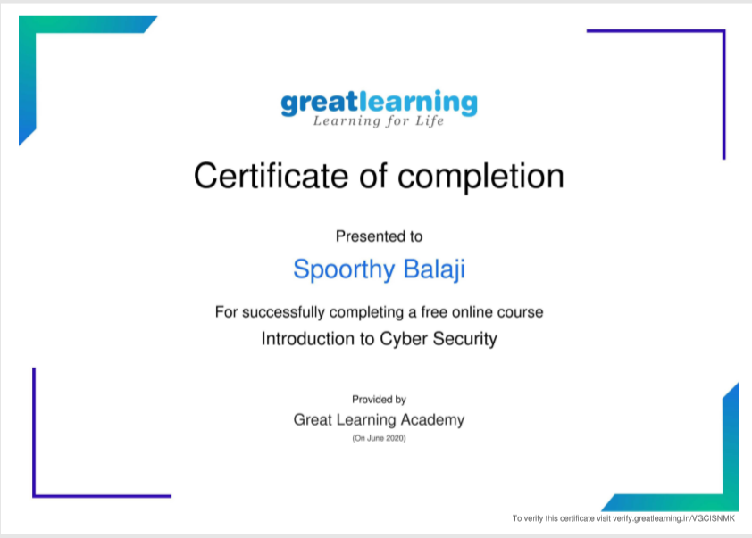

ONLINE CODING

Java Program:

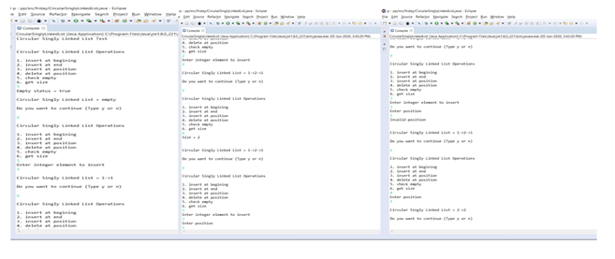

Python Program 1:

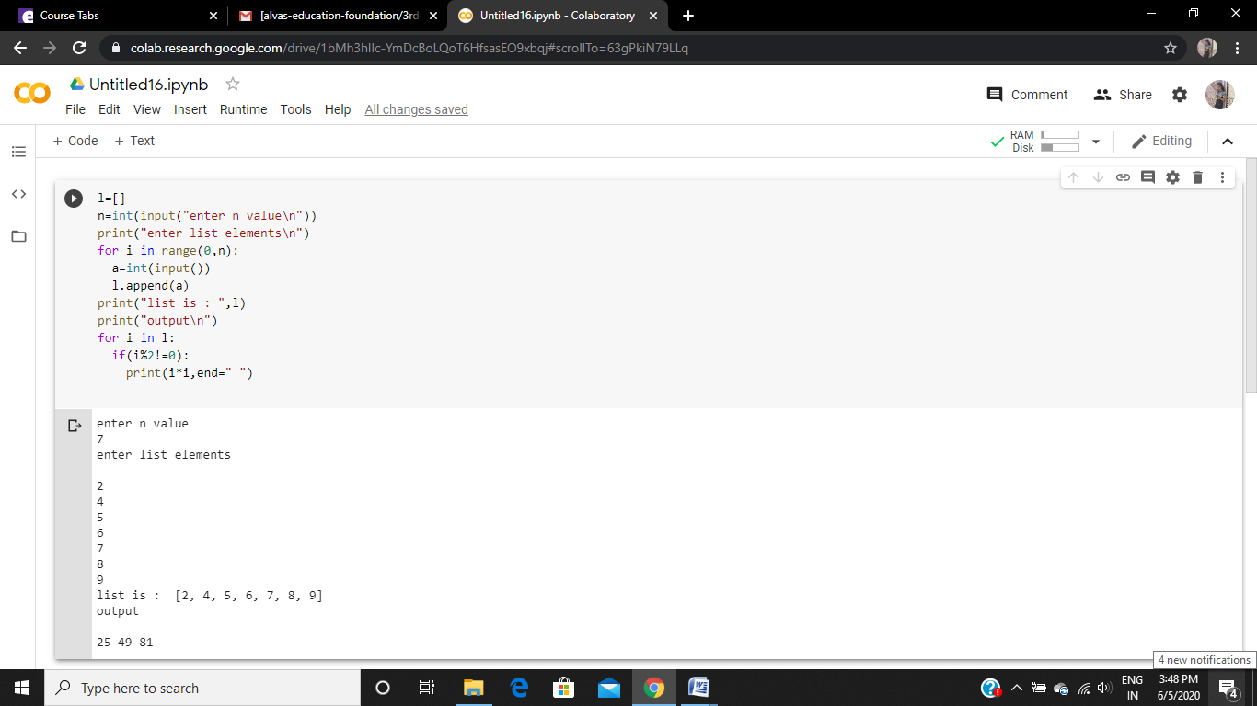

Python program 2:

